TRUE MOBILITY (The Case of Quadrobot)
© By: James Cook, Quadrobot CFO, Madison Heights, MI USA

Modern urban living is entering a new era where urban residents will be able to get anything, anywhere, at any time while owning nothing. The thing, the where, and the time will be resolved virtually, on the spur of the moment, by the internet, big data, and AI. These residents’ costs will be according to the momentary usage (use fee). Here in Michigan, the local automotive economy aptly named their new market, “MOBILITY”. However, Mobility requires, not a restructuring as was the case with small cars, lean manufacturing, and 6-sigma quality, rather Mobility requires a whole new way of thinking! Thinking must shift from logical, predictive, reductionistic to intuitive, probabilistic, holistic. Correspondingly, the engineering god, Simplicity, is being toppled by Nature’s god, Complexity.
Mobility is inherently complex, and can only be understood if its manifestations are considered simultaneously. Ride hailing, by itself, is not Mobility, in fact, nothing, by itself, constitutes Mobility. Mobility is the so-called “smart” movement of the city’s people and goods. The internet, big data, and AI has made possible the what, where, and when. That is the virtual half of the Mobility satisfaction. The how, the physical half of Mobility fulfillment, is the heavy lifting and that’s where Quadrobot’s stunning business model and vehicle design stand out. The financial half (third half, I know) is the stochastic demand that is omni-present in both time and place, and is where versatility becomes crucial.
Quadrobot’s unique platform can be morphed over the course of a day into many of Mobility’s needs from delivery (which is our initial foray) to ride hailing/sharing, and special purposes such as lunch wagons, retailing/vending on wheels, even street cleaners. Quadrobot’s proprietary, all-electric, van has two unique features: a swappable body (analogous to standard shipping containers on a personal scale) that allows switching to match the rhythm of the day (from commuting to delivering to lunch wagon ...), and a vehicle that is narrow and low enough to facilitate easy and quick urban access and maneuverability. Add to this, all Quadrobot’s vans are autonomous ready, internet tethered, and transparently useful as data harvesting vehicles while doing other jobs, as a way to reduce lease payments and/or generate significant additional income streams.
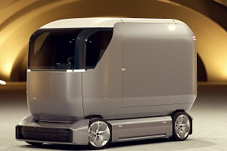 | 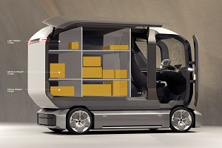 | 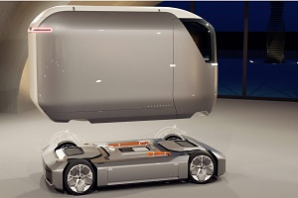 | 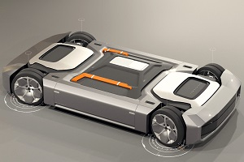 | 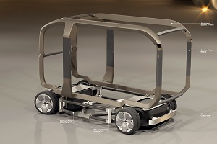
Smart-ness enabled with internet for tracking and optimization, 75% cargo space (106 ft³, 3.0 m³), interchangeable and extendable batteries. | Convenient access, single door/side rests on roof, sized to single shift load, (back door opens out), doors automatically lock, body easily customizable. | Can change chassis/body configurations for different applications: delivery, ride hailing, lunch wagon, mobile vending, street cleaning. | Custom designed for cities’ alleys and bicycle paths, completely symmetrical power train modules, and four independently controlled wheels. | Modular design enables small volume assembly and quick repair. Use of aluminum and carbon fibers resists wear noise, and structural fatigue.
The genius behind Quadrobot’s versatile design is Mike Wang, CEO. As a graduate of College of Creative Studies, he was a student of John Manoogian’s (retired GM chief car designer and now on Quadrobot’s board). Mike grew up in Hangzhou China, the capital of e-commerce, and came to Detroit, the capital of vehicle design. He used these two immersions to inspire the design of a vehicle to transform e-commerce and become a platform for serving urban Mobility. Now in 2019, he’s setting up Quadrobot’s world headquarters in Greater Detroit while launching Quadrobot’s delivery van for service in Hangzhou. This year, 2019, the Postal Ministry has committed to using over one thousand Quadrobots to deliver packages in several major cities, plus two hundred designated by the government as “A Smart City of the Future” exemplar.
From these beginnings, Quadrobot will take a leading position in the Mobility marketplace through proprietary designs, appropriate business models, and creative financing and partnering. Quadrobot’s success, we believe, will ultimately derive from our superior alignment with the needs and desires of TRUE MOBILITY!

